Lakhveer Kaur

**Heat Events in California**

Introduction: In this analysis, we want to find how heat events change in future in CA. Instead of getting data for all cities in CA, we chose to work with only five major cities, namely, Sacramento, San Diego, Los Angles, Santa Barbara, Fresno, and San Jose, to get data. In every city, we find all the days where daily temperature exceeds 90th percentile of its corresponding historic temperature. We kept only hot days that were common in all five cities. Since we are looking only for heat events, we will consider only May, June, July, Aug, and September months.

Variables:

* Resource: locagrid
* Climate variable: tmax
* Model: CanESM2 (for this report only)
* Scenario: RCP 8.5
* Location: Sacramento, San Diego, Los Angles, Santa Barbara, Fresno, San Jose

Below are the steps that we followed to find the hot days in CA:

1. Find the 90th percentile of historic data (1961-1990) in all 5 cities
2. Find all the days is every city which has temperature higher than its corresponding 90th percentile historic value
3. Keep only the days that are common in all cities.
4. Take average of tmax in all cities.
5. Plot these days on a graph

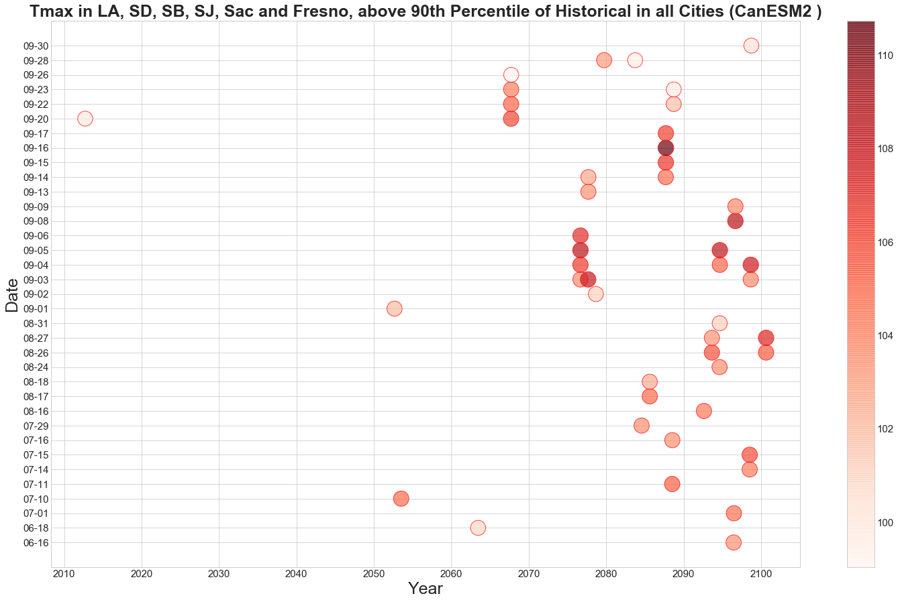

In the graph above, each bubble is a day which meets the above requirements (tmax is higher than 90th percentile of historic values in each city). Color shows the average of five cities t-max temperature on that specific day. Darker the color is, higher the temperature is on that day.

Conclusion: There was only one day in first half century where temperature was higher than 90th percentile in all the cities. However, in later half of the century, this number drastically increase. Also, note that, Hot days go from Mid-June to End of November unlike the summer season in historical data.